Storage event trigger

In storage account orders csv file arrives according to date and we want to add that data to orders table in sql using triggers whenever file arrives in adls

1. Create storage account
2. Craeate container create folder dept
3. Create sql table dept
4. Go to adf crate linked service
5. Create trigger select storage events in trigger

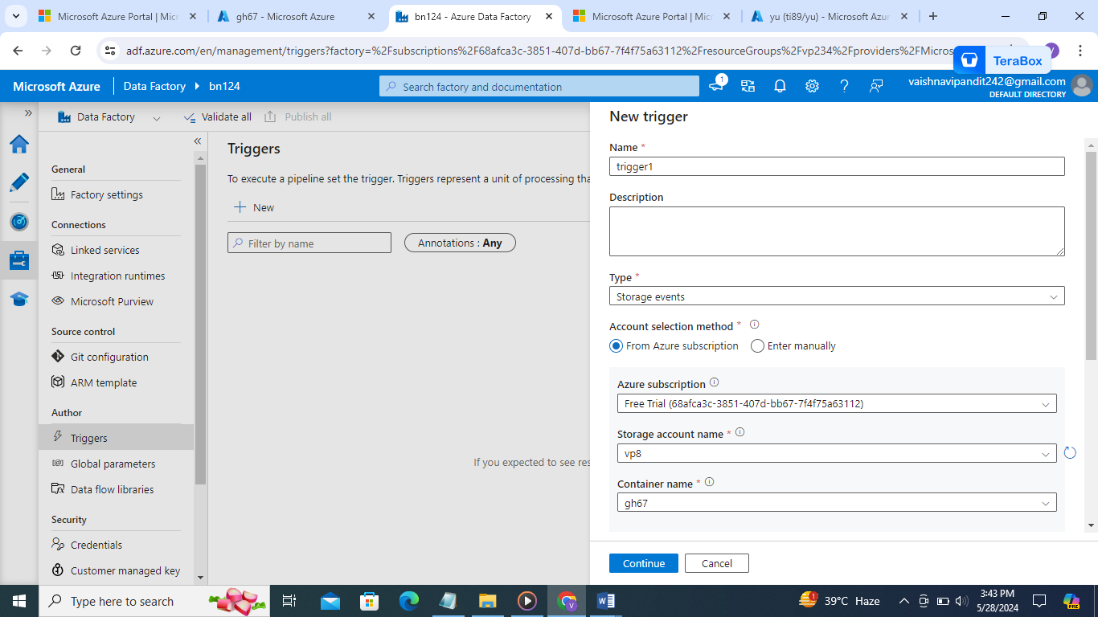

1. Select stat path add dept/->folder name and end path

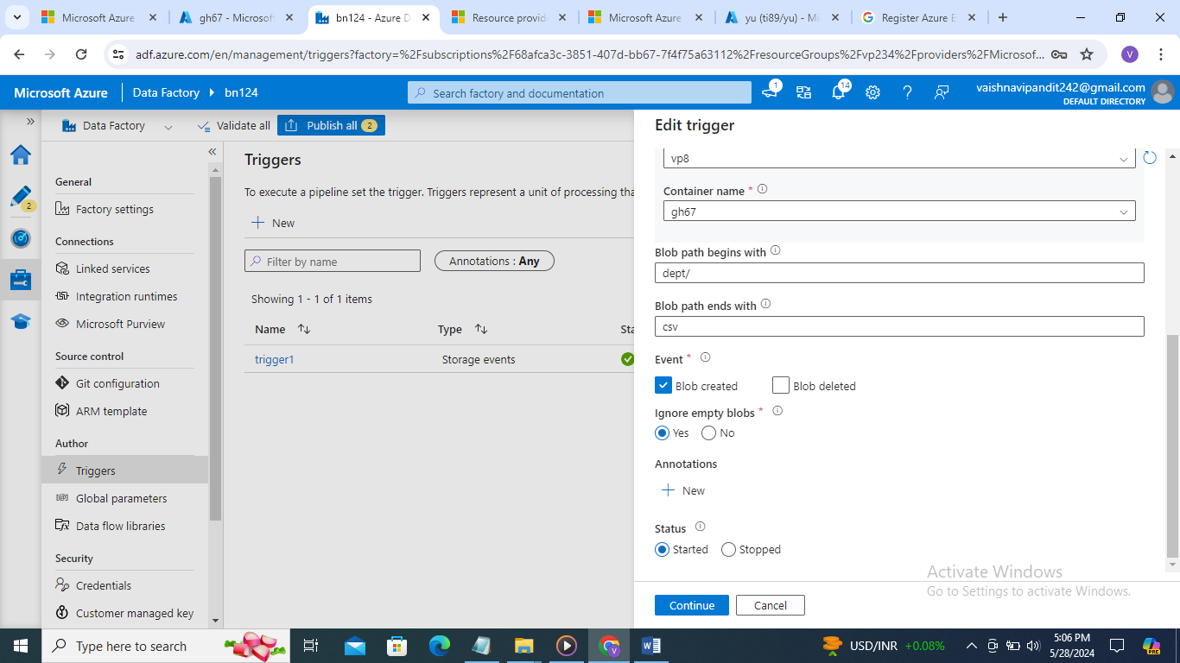

1. Go to azure data factory create pipeline to copy data activity

Source->wildcard path

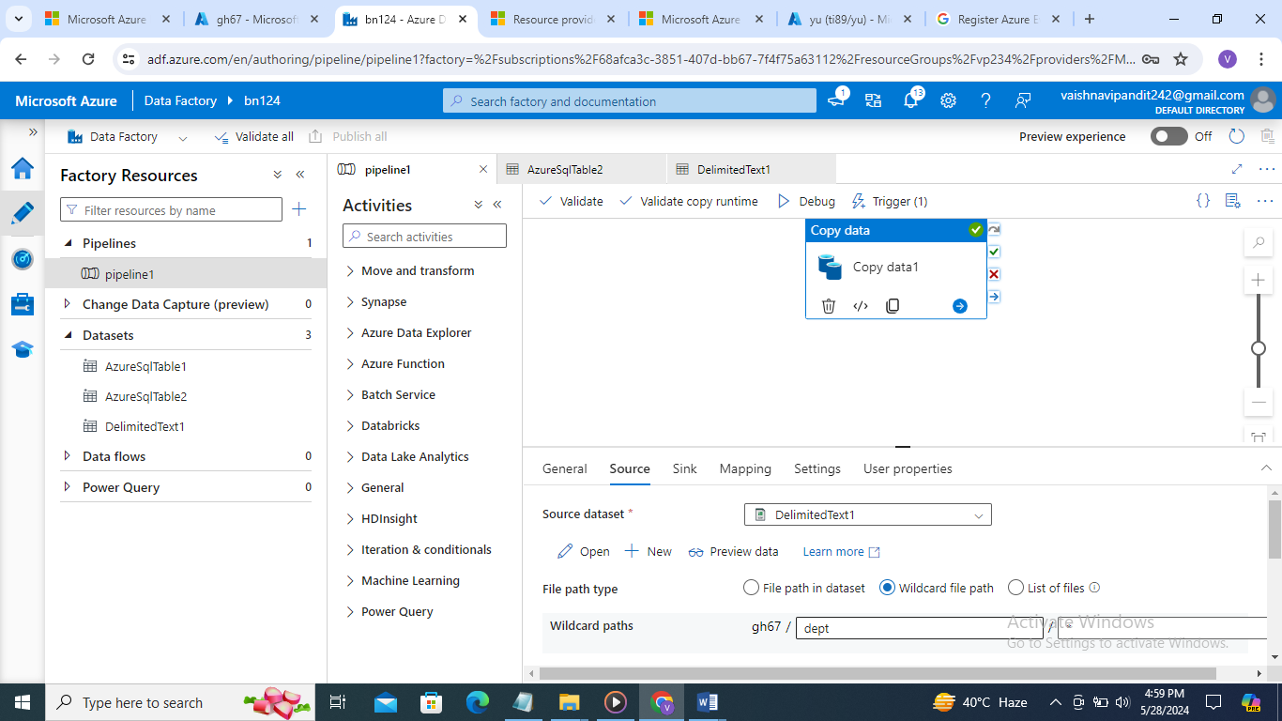

Sink sql

1. Now add triggers

And add that created trigger

publish